1.
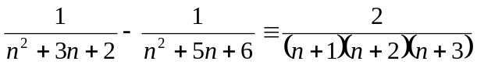 , 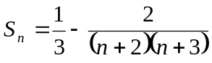 , 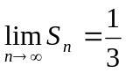

2.
Prove by mathematical induction.

3.
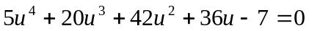 , 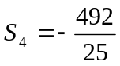

4.
Asymptotes : 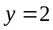 , 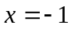 , 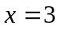
Axial intercepts : 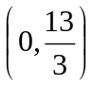 , 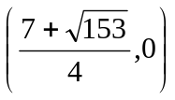, 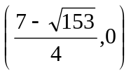
Local maximum point : 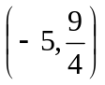 , local minimum point : 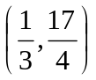

5.
(a) 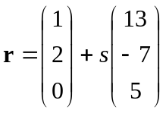
(b) 